# **Chapter 2**

# **Analysis**

**2.1 Introduction**

Analysis is the process of studying the components part of system. Its is the process to consider system carefully and using statistical methods for best system design. Analysis is the most important part in development of the system. Without analysis project fails due to lack of system analysis so, different types of research, methods function requirements should be done to develop system. It helps to find different source which breaks a complex topic into smaller part for better understanding.

**2.2 Analysis Methodology**

The analysis methodology is well organized by analytical functions which gives knowledge about applying data analysis system functionality, making decision.

In analysis phase I am using Strengths, Weaknesses, Opportunities, Threats (SWOT) analysis.

It studies by an organization to identify strengths and weakness as well as opportunities for employees and threats in organization.

**Strengths, Weaknesses, Opportunities, Threats (SWOT) Analysis**

In my project strengths will play a vital role. It provides an advantage over others in project. Were as weakness which will help us to know about the disadvantage of project relative to others. Opportunities where elements in the environment that the business or project could exploit to its advantage. Threats where elements in the environment which could cause trouble in the project. SWOT analysis identifies the internal and external factors where strengths and weakness are internal to the project and opportunities and threats are external to the project.

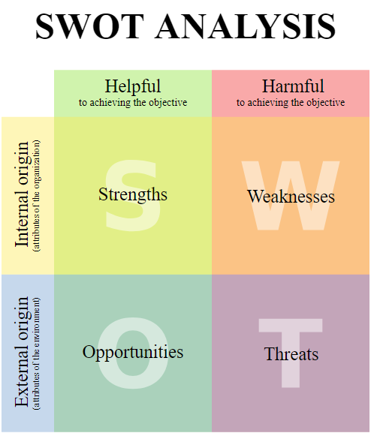

**Fig1: SWOT Analysis**

The reason for choosing SWOT analysis rather than other paradigms:

**Merits**

* Factor Identification

It is the primary advantage of using SWOT analysis. In project it will allows internal and external factors which are favorable and unfavorable to objectives. This allows an organization or company to understand and support in assessing core competencies.

* Simplicity

Using SWOT analysis for analyzing process individual not require proper technical skills or special training. Any individual or a team with right decision and their knowledge, skills about project will help easily to perform SWOT analysis,

* Wide application

This is one of the advantages of SWOT analysis which has also been used to analyze situation of particular business, specific project, individual or a team which provides overview of internal and external situation.

**Demerits**

* Prone to ambiguity

The SWOT framework does not provide a mechanism dealing with overlaps. Performing SWOT analysis, it generates a long list of strengths, weakness, opportunities and threats.

* Tendency to be subjective

Performing a SWOT analysis, it does not require technical skills, it is more important to put emphasis on fact system should be driven by research and data. SWOT analysis is simple to use so it is disadvantage because it can be quickly designed and performed.

**2.3 Feasibility Study**

A feasibility study is an important factor for success in project. It is used to determine idea such as technical and legal feasibility also economic justifiable. In my project it will help to study for potential investors and lending institutions. So, there are five types of feasibility study which as explain below for project.

* Technical Feasibility

It focuses on technical resources which is available to project. It will determine technical resources which are capable to meet ideas into systems. In my project I will use hardware, software.

* Economic Feasibility

It focuses on the benefits analysis of project where it will help to determine viability, costs before financial resources which are allocated. It will help to determine positive economic benefits to the system.

* Legal Feasibility

A legal feasibility study proposed project conflicts with legal requirements like laws, data protection, social media laws. It might

* Operational Feasibility – Control efficiency, & services

Operational feasibility study how a project plan satisfies the requirements which identified in the requirements analysis phase of system development.

It helps to analyze and determine whether system will be met by completing the project.

* Schedule Feasibility – Timeline estimations & optimizing resources

Schedule feasibility is the most important for project success, if the need is not completed on time then project will fail. It this organization estimates time for project how much it will take to complete.

**2.4 Software Requirements Specification**

A software requirements specification (SRS) is a description of a software system to be developed with functional and non-functional requirements. We should have clear understanding of software system so, that this will help to develop project and help us to achieve needs gathering from customers requirements.

**2.4.1 Functional Requirements**

1. **Login Module**
2. **New Profile Module**
3. **Customer Module**
4. **Admin Module**
5. **Submit Button**
6. **Payment Option**
7. **Update shipment status**
8. **Cancelation**
9. **Cookies**
10. **Display Module**
11. **Comment**
12. **Logout**

**2.4.2 Non-Functional Requirements**

1. **Security**
2. **Maintainability**
3. **Supportability**
4. **Reliability**
5. **Scalability**
6. **Usability**
7. **Performance**

|  |  |  |  |  |  |
| --- | --- | --- | --- | --- | --- |
| **ID** | **Requirement Specification** | **Description** | **Rational** | **Dependency** | **Remarks** |
| **FR1** | **Login** | **User can use their Id and password to get access into their account** | **To get user login** | **FR2** | **Must have** |
| **FR2** | **Add New Profile** | **Customer have to create new user if he/she doesn’t have user id & password** | **To create new user profile** | **FR1** | **Must have** |
| **FR3** | **Customer Module** | **Customer can see all the transaction details and day to day activities** | **To have details of dealership** | **FR1, FR2** | **Should have** |
| **FR4** | **Admin Module** | **Admin Module where admin have all the access of courier software system** | **To have details of all the transaction** | **FR1, FR2** | **Must have** |
| **FR5** | **Submit Button** | **The main button which will confirm booking** | **Confirmation Button** |  | **Must have** |
| **FR6** | **Delete** | **If booking is need to be cancel then delete button may be used to delete.** | **Cancellation** | **FR8, FR10** | **Should have** |
| **FR7** | **Comment** | **Where customer can provide full details of goods** | **Feedback from customer** |  | **Could have** |
| **FR8** | **Update** | **Some time details may be update so it is used to update details.** | **To edit or update if necessary** | **FR6, FR10** | **Should have** |
| **FR9** | **Payment Method** | **Easy method for payment where customer can do from their home** | **Online Payment** |  | **Could have** |
| **FR10** | **Remove User** | **Customer may need to remove after they don’t need account, they can use remove user feature** | **To remove user if necessary** | **FR8, FR6** | **Should have** |
| **NFR11** | **Security** | **Most needed details but be safe and shouldn’t be leak.** | **To protect from hackers** | **FR4** | **Must have** |
| **NFR12** | **Maintainability** | **Need to be maintain software timely** | **To maintain before any issues** | **FR10** | **Should have** |

The above listed are functional and non-functional requirements which are used in my project. These are the main requirements of my project to complete. If the requirements are not fulfilled that project will be incomplete.

**2.4.3 MoSCoW Prioritization**

MoSCoW Prioritization is technique for managing requirements. It is commonly used to help key stakeholders to understand the significance of initiatives in a specific release. MoSCoW stands for ‘M’ for Must have, ‘S’ for Should have, ‘C’ for could have and ‘W’ for Won’t have.

**Must have**

In system labeled as Must have is most needed in system to be success. If even one Must have requirement is not included that the whole project will fail. It occupies 60% in whole project.

**Should have**

In system Should have are important but not that much necessary. Should have requirement can be important as Must have but not there may be another way to satisfy the requirement. It occupies 20% in whole project.

**Could have**

In system Could have are desirable but not necessary and could have satisfaction for a little development cost. This will be included if time and resources permit. It occupies 20% in whole project

**Won’t have**

Requirements which are not appropriate at the time.

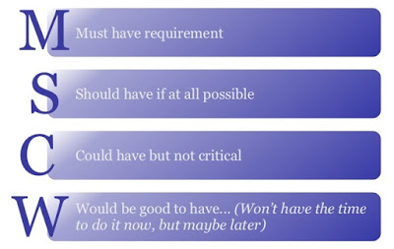

**Fig 2: MoSCoW**

|  |  |  |
| --- | --- | --- |
| **ID** | **Requirement Specification** | **MoSCoW Prioritization** |
| **F1** | **Login** | **Must have** |
| **F2** | **Add New Profile** | **Must have** |
| **F3** | **Customer Module** | **Should have** |
| **F4** | **Admin Module** | **Must have** |
| **F5** | **Submit Button** | **Must have** |
| **F6** | **Delete** | **Should have** |
| **F7** | **Comment** | **Could have** |
| **F8** | **Update** | **Should have** |
| **F9** | **Payment Method** | **Could have** |
| **F10** | **Remove User** | **Should have** |
| **F11** | **Security** | **Must have** |

**2.4.4 Hardware Software Specification**

The most needful requirement for system is Hardware and Software. The physical computer sources are known as hardware. It is a list of hardware compatibility list. Like wise in other hand, Software requirements defines the resource requirements that need to be installed on a computer to provide functioning of an application.

The following are the Hardware and Software specification:

**Hardware Specification**

1. **Laptop**
2. **Operating System**
3. **Architecture**
4. **Memory**
5. **Power Processing**
6. **Hard drive**

**Software Specification**

1. **Installation Tools**
2. **Star UML**
3. **PHP Strom**
4. **XAMPP**
5. **Database**
6. **Chrome**

These are the Hardware and Software which I am going to use in my project. Hardware and Software are inter connected with out software hardware is use less and without software hardware cannot be used.

**2.5 Use Case Diagram**

A use case diagram is a methodology used in system analysis to identify, clarify and organize system requirements. It is a set of actions, services, and functions which need to perform by system. It is drawn in Unified Modeling Language (UML). n this diagram model the functionality is using actors and use cases. Actors represents role that are played by users of the system. The main purpose of use cases is to gather system specific requirements and actors.

The diagram of my project is shown below:

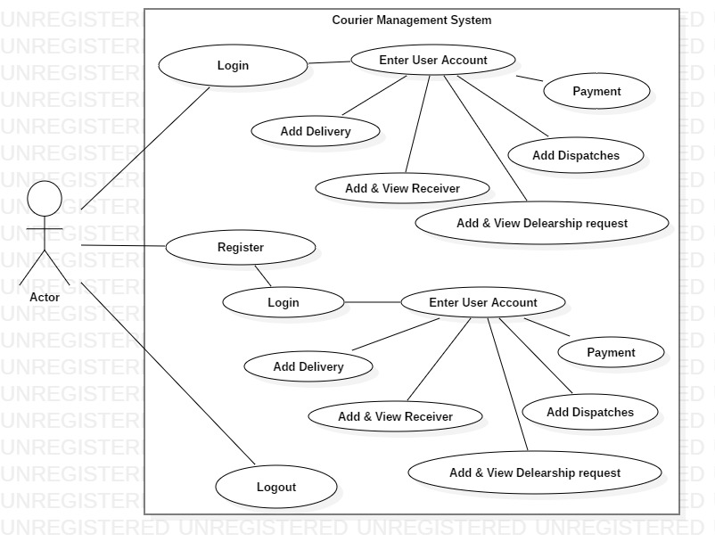

**Fig 1 Use case Diagram (Actor)**

Above use case diagram shows actor role which can be used by users in my project. First, user can login in if he/she have login id, if not they can register their name so that it would be easy for them to use system again. Actor can add delivery, add dispatch, add and view dealership request and also add view receivers. This would make easy for user to know details about their courier package.

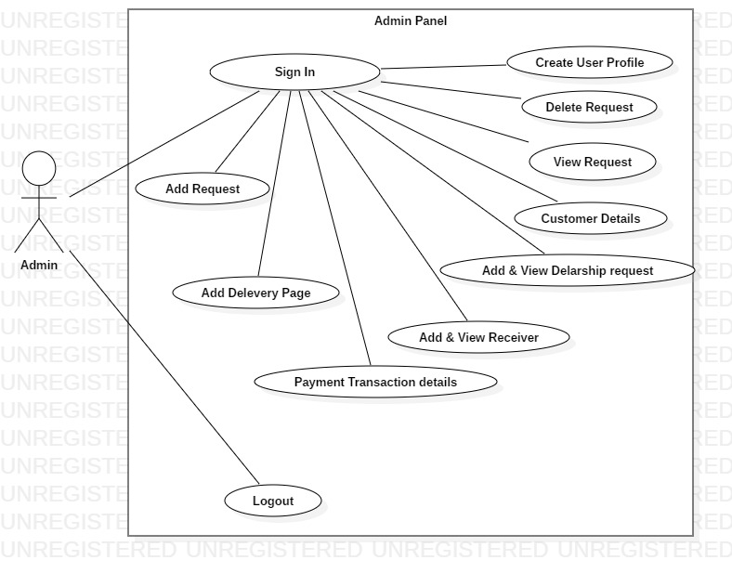

**Fig 2 Use case Diagram (Admin)**

Likewise, admin use case shows in admin panel where after sign up admin can add, view, update and delete request, add and can view dealership request, add delivery page and also add view receiver. This would help admin to have records of all the customers details.

**2.6 Initial Class Diagram (NLA)**

**Courier Management System**

Our courier service provided 24 hours a day, 7 days a week, 365 days a year. This is online booking courier delivery software system. Courier Management System makes your business our business. Our service will be used for managing day to day activities like booking, pickup, receiving incoming couriers and account management.

Online booking system provides personal user profile for customer. You can book their all details for goods dispatch. If goods are not need to be send then you can cancel the booked. You have access to view dealership details where you can view all the details of goods added for delivery. Online payment also can be done if customer wants to pay online. When first time an order is placed your customer log in portal can be used forever.

It will be auto generated email notification for received parcel, dispatch parcel with complete details.

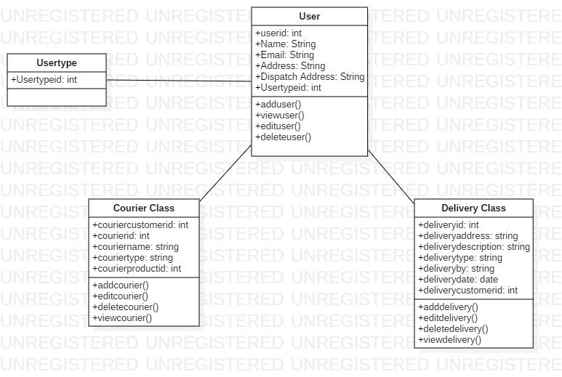

**Initial Class Diagram**

**NLA**

|  |  |  |
| --- | --- | --- |
| **S. NO** | **Noun identification** | **Selected as candidate or not?** |
| 1 | Online | Yes |
| 2 | Business | No |
| 3 | System | No |
| 4 | Pickup | Yes |
| 5 | Notification | No |
| 6 | Customer | Yes |
| 7 | Booking | Yes |
| 8 | Dispatch | Yes |
| 9 | View | No |
| 10 | Access | No |
| 11 | Payment | No |
| 12 | log | No |
| 13 | Portal | No |

|  |  |
| --- | --- |
| *Filtered list of the Noun* | |
| 1 | Online |
| 2 | Pickup |
| 3 | Customer |
| 4 | Booking |
| 5 | Dispatch |

|  |  |  |
| --- | --- | --- |
| **S. NO** | **Verb identification** | **Selected as candidate or not?** |
| 1 | Service | No |
| 2 | Delivery | Yes |
| 3 | Receiving | Yes |
| 4 | Cancel | Yes |
| 5 | Use | No |

|  |  |
| --- | --- |
| *Filtered list of the Noun* | |
| 1 | Delivery |
| 2 | Receiving |
| 3 | Cancel |